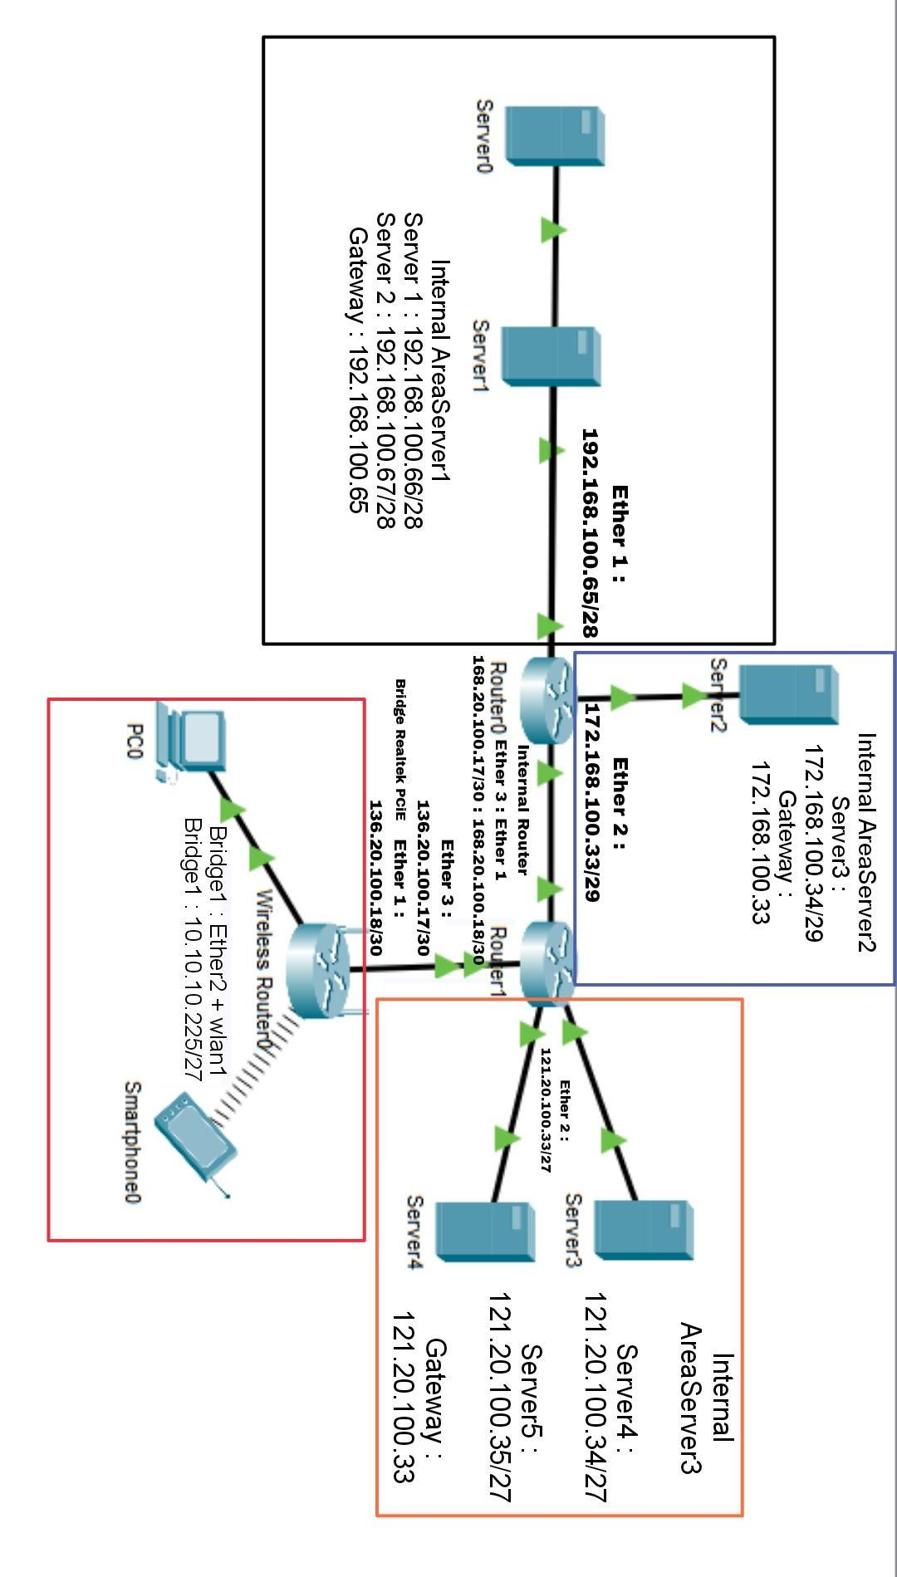

**Routing Table :**

RTB 1 :

nano /etc/sysctl.conf

Hapus pagar pada #inet.ipv4.ip_forward = 1

nano /proc/sys/net/ipv4/ip_forward

Ubah 0 menjadi 1

RTB 2 :

Ip route add dst-address=192.168.100.64/28 gateway=168.20.100.17

Ip route add dst-address=172.168.100.32/29 gateway=168.20.100.17

Ip route add dst-address=10.10.10.224/27 gateway=136.20.100.18

Ip route add dst-address=0.0.0.0/0 gateway=136.20.100.18

RTB 3 :

Ip route add dst-address=192.168.100.64/28 gateway=136.20.100.17

Ip route add dst-address=172.168.100.32/29 gateway=136.20.100.17

Ip route add dst-address=121.20.100.32/27 gateway=136.20.100.17

Ip route add dst-address=168.20.100.16/30 gateway=136.20.100.17

**Konfigurasi Internet dan Bridge RTB 3**

Ip dhcp-client add interface=lte1 disabled=no

Ip firewall nat add chain=srcnat out-interface=lte1 action=masquerade

Interfaces wireless enable 0

Interfaces wireless set 0 mode=ap-bridge ssid=testing

Interface bridge add name=bridge1

Interface bridge ports add interface=ether2 bridge=bridge1

Interface bridge ports add interface=wlan1 bridge=bridge1

Ip address add address=136.20.100.18/30 interface=ether1

Ip address add address=10.10.10.224/27 interface=bridge1

**Sudo dan SSH (Semua server)**

Adduser adminserver dengan password Sumut2023

Nano /etc/sudoers

Adminserver ALL=(ALL:ALL) ALL

Nano /etc/ssh/sshd_config

Port 2223

PermitRootLogin no

AllowUsers adminserver

Service ssh restart

**DNS**

Atur DNS semua server dan RTB 1 dengan cara :

nano /etc/resolv.conf

Tambahkan :

nameserver 192.168.100.66

nameserver 192.168.100.67

nameserver 1.1.1.1 (tambahkan dns ini hanya saat menginstall package saja)

Atur DNS pada RTB 2 dan RTB 3 dengan cara :

Ip dns add server=192.168.100.66,192.168.100.67,1.1.1.1

Ip dns set allow-remote-request=yes

**Konfigurasi DNS Master di Server1 :**

apt install bind9

cd /etc/bind

cp db.local lkssumut

cp db.local indojuara

cp db.127 reverse

nano named.conf.local

*Zone forward artinya zone yang menerjemahkan nama domain menjadi IP contoh = lkssumut.net > 192.168.100.66

*Zone Reverse artinya kebalikan dari zone forward yaitu menerjemahkan IP menjadi nama domain contoh =

192.168.100.66 > lkssumut.net

Tambahkan zone forward dan reverse :

zone “lkssumut.net”{

type master;

file “/etc/bind/lkssumut”;

allow-transfer {192.168.100.67;};

also-notify {192.168.100.67;};

};

zone “indojuara.net”{

type master;

file “/etc/bind/indojuara”;

allow-transfer {192.168.100.67;};

also-notify {192.168.100.67;};

};

zone “100.168.192.in-addr.arpa”{

type master;

file “/etc/bind/reverse”;

allow-transfer {192.168.100.67;};

also-notify {192.168.100.67;};

};

nano lkssumut

tambahkan nameserver ns1 dan ns2 untuk DNS master dan slave

@ iN NS ns1.lkssumut.net.

@ IN NS ns2.lkssumut.net.

@ IN A 192.168.100.66

ns1 IN A 192.168.100.66

ns2 IN A 192.168.100.67

www IN A 121.20.100.34

mail IN A 121.20.100.34

client IN A 121.20.100.35

ntp IN A 172.168.100.34

nano indojuara

tambahkan nameserver ns1 dan ns2 untuk DNS master dan slave

@ iN NS ns1.indojuara.net.

@ IN NS ns2.indojuara.net.

@ IN A 192.168.100.66

ns1 IN A 192.168.100.66

ns2 IN A 192.168.100.67

www IN A 121.20.100.34

nano reverse

tambahkan reverse pointer untuk domain dan nameserver lkssumut

@ IN NS ns1.lkssumut.net.

@ IN NS ns2.lkssumut.net.

66 IN PTR lkssumut.net.

66 IN PTR ns1.lkssumut.net.

67 IN PTR ns2.lkssumut.net.

service bind9 restart

**Konfigurasi DNS Slave di Server2 :**

apt install bind9

cd /etc/bind

nano named.conf.local

zone “lkssumut.net”{

type slave;

file “/var/cache/bind/lkssumut”;

masters {192.168.100.66;};

allow-notify {192.168.100.66;};

};

zone “indojuara.net”{

type slave;

file “/var/cache/bind/indojuara”;

masters {192.168.100.66;};

allow-notify {192.168.100.66;};

};

zone “100.168.192.in-addr.arpa”{

type slave;

file “/var/cache/bind/reverse”;

masters {192.168.100.66;};

allow-notify {192.168.100.66;};

};

service bind9 restart

**Web Server**

**Konfigurasi Website http://www.lkssumut.net dan http://www.indojuara.net di Server 4**

apt install apache2

cd /var/www

mkdir lkssumut

mkdir indojuara

nano lkssumut/index.html

<html>

<h1>Selamat Datang di Website LKS SUMUT</h1>

</html>

cp lkssumut/index.html indojuara/index.html

nano indojuara/index.html

<html>

<h1>Selamat Datang di Website INDOJUARA</h1>

</html>

cd /etc/apache2/sites-available

cp 000-default.conf lkssumut.conf

cp 000-default.conf indojuara.conf

nano lkssumut.conf

ServerName www.lkssumut.net

DocumentRoot /var/www/lkssumut

nano indojuara.conf

ServerName www.indojuara.net

DocumentRoot /var/www/indojuara

a2dissite 000-default

a2ensite lkssumut

a2ensite indojuara

service apache2 restart

**NTP (Server3)**

Apt install ntp

Nano /etc/ntp.conf

Server ntp.lkssumut.net iburst dynamic

Server 127.127.1.0

Fudge 127.127.1.0 stratum 1

Restrict 192.168.100.64 mask 255.255.255.240 nomodify notrap

Restrict 10.10.10.224 mask 255.255.255.224 nomodify notrap

Service ntp restart

Ntpq –p

**FTP (Server 3)**

Adduser adminftp

Mkdir /share

Chmod –R 777 /share (*penjelasan –R untuk mengubah hak akses terhadap direktori/file yg berada di dalam direktori /share, 777 artinya memberikan akses penuh (4 = read,2 = write, 1 = execute, 7 = read,write,execute) untuk semua user, group, dan others)

Nano /etc/proftpd/proftpd.conf

Port 2121

DefaultRoot /share adminftp

<Anonymous /share>

User ftp

Group nogroup

UserAlias anonymous ftp

RequireValidShell off

</Anonymous>

Service proftpd restart

**FTP (Server 5)**

Adduser clientweb

Mkdir /var/www/webapp

Chown –R clientweb:clientweb /var/www/webapp

Chmod –R 771 /var/www/webapp

Nano /etc/proftpd/proftpd.conf

Port 8021

DefaultRoot /var/www/webapp clientweb

Service proftpd restart